Douglas Bentham: Poetry In Steel
MJM&AG Permanent Collection
September 15 - December 31, 2016
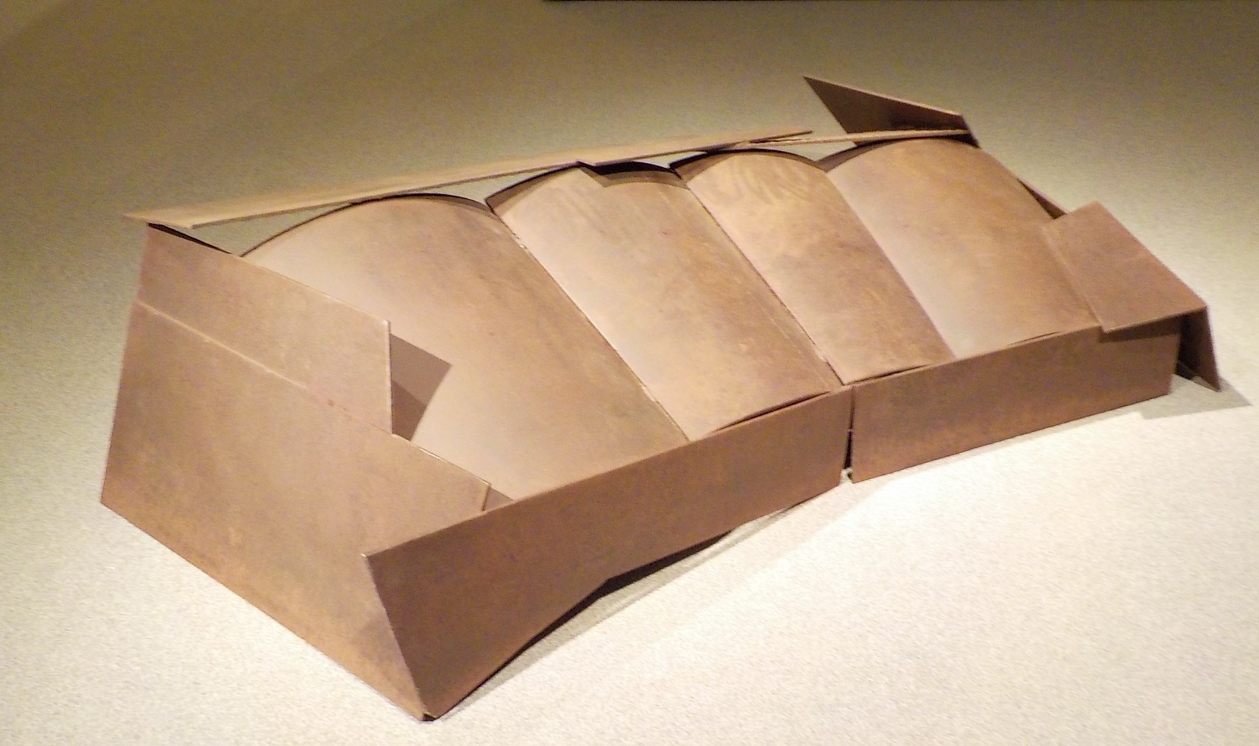
It is a pleasure to present some of Douglas Bentham’s works in the Moose Jaw Museum & Art Gallery Permanent Collection, alongside his exhibition The Tablets, to not only have the opportunity to highlight these significant works in the collection, but to offer a glimpse into the evolution of this artist’s distinctive sculptural practice. Known for his large welded-metal structures, Bentham is recognized as one of Canada’s most prominent sculptors and has made a profound contribution to modernist art and sculpture in Saskatchewan and Canada.

Saskatchewan has a prominent tradition of modernist, welded-metal sculpture, one that can be traced back through degrees of separation to British sculptor Henry Moore and American sculptor David Smith. These internationally renowned sculptors took Picasso’s lead in abandoning the traditional art of modelling in sculpture in favour of assemblage and construction, finding endless possibilities in exploring mass, volume and form through additive and subtractive approaches. Coming out of a Cubist concern for spatial form and a Constructivist sensibility for materials, volume and space, modernist sculpture in Saskatchewan was shaped not only by artists such as Otto Rogers, Bill Epp, Eli Bornstein and John Nugent in the university sculpture departments in Saskatoon and Regina, but also through the Emma Lake Artists’ Workshops, where participants were exposed to the ideas and working methods of leading, international artists, such as Michael Steiner and Anthony Caro. Steiner’s workshop in 1969 shared sculptural approaches and modernist theories coming out of New York to a new group of younger artists, introducing concepts towards a reductive formalism and the universal values it embodied. British sculptor Anthony Caro’s participation at Emma Lake as a guest artist in 1977 no doubt made an impact on participants, including Bentham, who was a lead organizer of the event. Caro had gained widespread international attention by 1963 for exhibiting large, brightly painted abstract sculptures placed directly on the ground, removed from the pedestal, so that they could engage viewers on a one-to-one basis, a radical departure from the way sculpture had been seen in the past.

Influenced by this strong artistic lineage, Doug Bentham has made his own significant contributions to modernist sculpture in Canada. His sculptural practice reflects a clear commitment to a modernist vision and a constructivist sensibility - a sincere engagement with form, materials and how sculpture occupies space. Works like Piece #27, from his Enclosure Series in 1975, are placed not only directly on the ground but in relation to it, forcing the viewer into a specific viewing perspective to become aware of the space surrounding the work and to consider how the work animates its environment. With only a hint of the interior space, the work encloses volume, making the floor or ground that it covers a part of the piece. Prairie Open (1974), from his Opens Series, addresses the space surrounding a sculpture by framing that negative space, encouraging viewers to look through, around and beyond the form, to, again, consider how the work engages in its surroundings. Continually experimenting with materials (steel, aluminum, brass, bronze, wood) and surface finishes, Bentham throughout his esteemed practice has consistently challenged and pushed the traditional principles of sculpture – form, volume and space, guided by poetic impulses and philosophical inquiries.

Jennifer McRorie, Curator

Saskatchewan sculptor John Nugent visited the studio of David Smith while on a trip to New York in 1961, an encounter that influenced his move to working in welded steel abstraction. Anthony Caro, who worked as Henry Moore’s studio assistant early in his career, was a guest artist at the Emma Lake Artists’ Workshop in 1977.
Anthony Caro. Biography. Accessed September 12, 2016. http://www.anthonycaro.org/frames-related/biography.htm.
Christopher Youngs, Douglas Bentham: Articulations (Saskatoon: Mendel Art Gallery: 1984), 6.

